UE24CS242B: OPERATING SYSTEMS

Operating Systems Banana Problem
By
NAME: Tanmayi Nagabhairava
SECTION: I
SRN: PES1UG24CS493

The Hive Containment Protocol

PART A:

- The Hive startup message
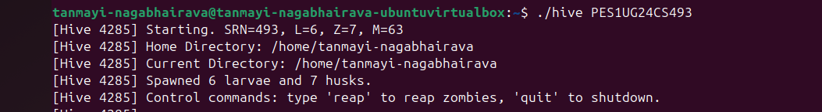
- The PID file contents
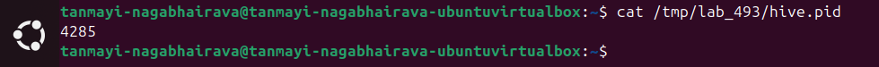
- Process listing showing all hive children
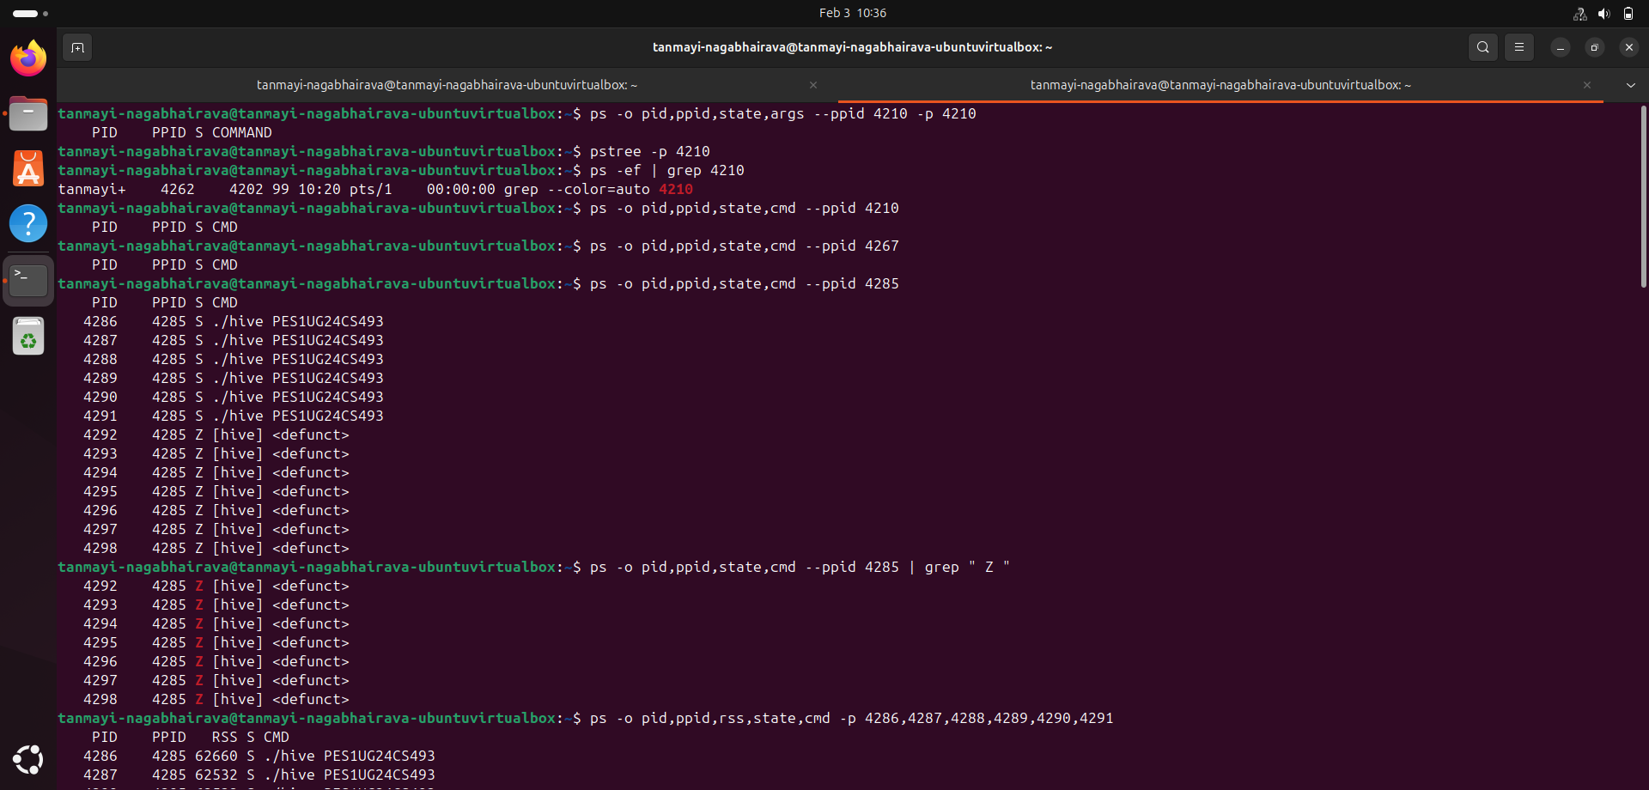
- List of zombie processes
- Memory usage for all larvae
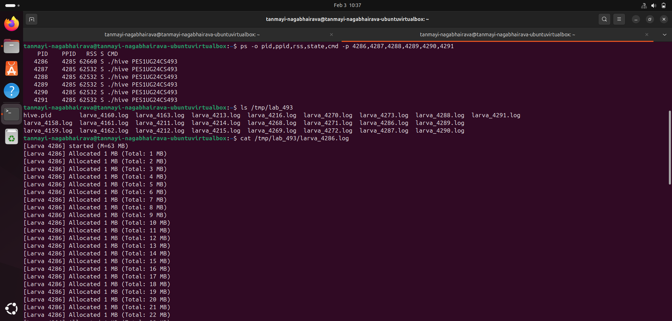
- Contents of one larva log file
- Terminal 1 showing the "Command received: reap" message
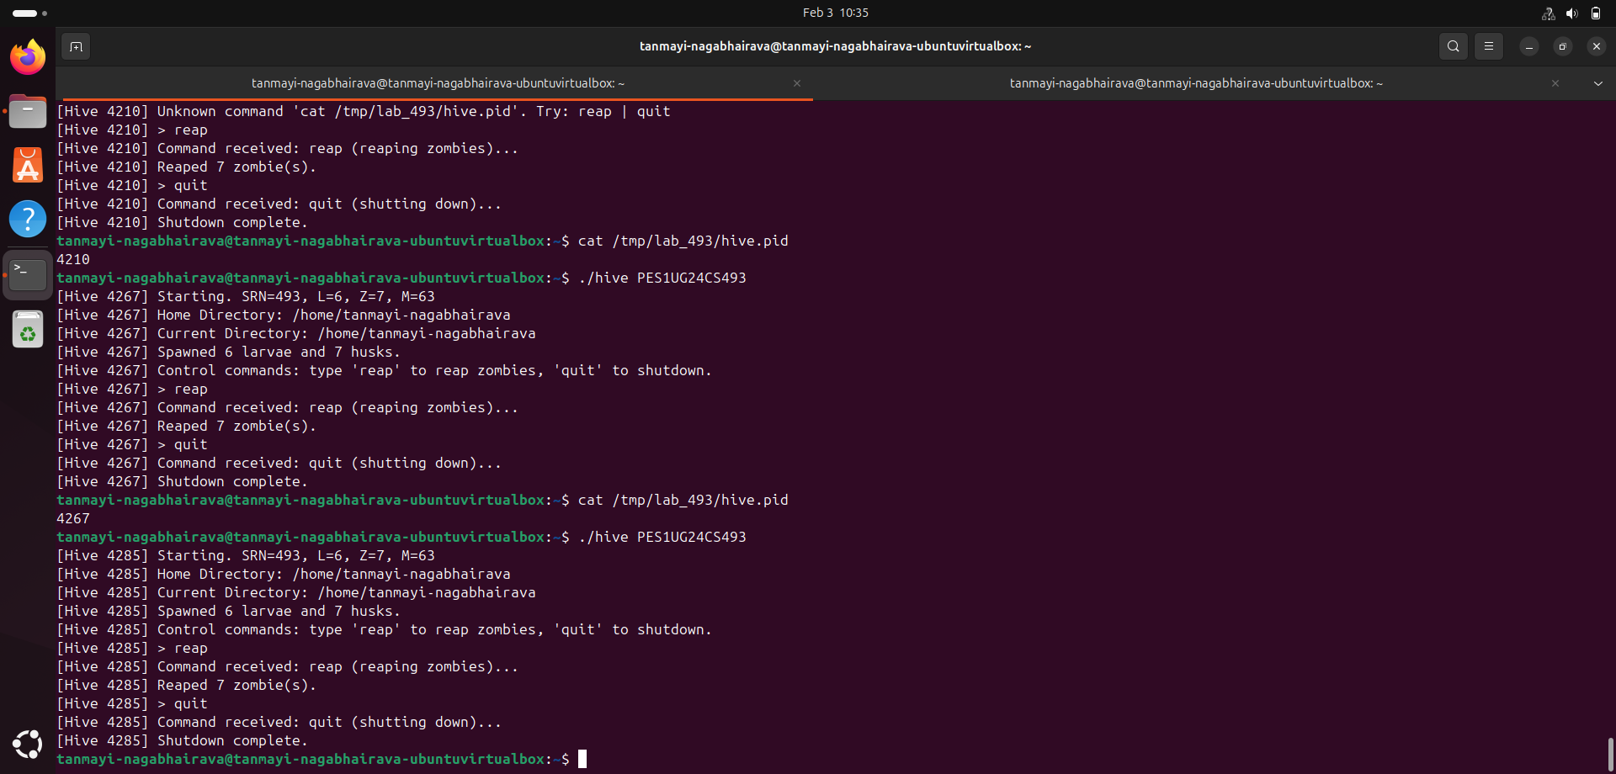
- Output showing zero zombies and
- Remaining children listing
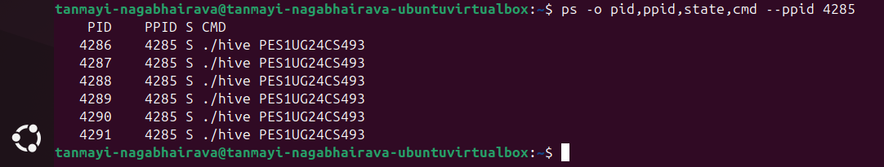
10. Terminal 1 showing shutdown message

PART B:

1. Verifying Parent/Child Relationships (PID/PPID)
The Process ID (PID) is a unique number assigned by the operating system to every active process to track it. The Parent Process ID (PPID) is the PID of the specific process that created the child using the fork() system call. You can check the relationship between the Hive and its children by checking if the PPID of each larva or husk corresponds to the PID of the Hive process. A command such as pstree -p is used to visually show this relationship by branching all larvae and husks directly under the Hive parent.

2. Parent Responsibility & Zombie Reaping
The reason for the existence of zombies is that the operating system maintains the status of a completed process in the process table so that the parent process can read it. The wait() or waitpid() system call is used by the parent to acknowledge the status and "reap" the child, so that the system can completely release the resources. If the parent does not reap its children, the entries in the process table would remain occupied, which would eventually make it impossible for the system to create new processes. The WNOHANG option turns the wait operation into a non-blocking operation, so that the Hive can check for dead children and remove them without halting its own execution and becoming unresponsive to user input.

3. Zombie Creation
The "Husk" processes are created with fork() and immediately invoke _exit(), so they end the moment they are born. They become zombies because the Hive parent is too busy waiting for the user's input and does not automatically invoke the reaping routine after creating them. The code on the parent side that is responsible for this is the main loop, which invokes the waitpid() reaping routine only when the user types the "reap" command.

4. Dormant Larvae
A Larva enters a while(1) pause() loop when there is a failure in memory allocation in order to live in the system rather than exiting. If the larvae were to simply exit, they would soon be reaped and would no longer be visible in the process list, effectively halting the influence of the Hive on the system. However, by being in a paused state, they remain visible in the process listing utilities such as ps, ensuring that they continue to occupy slots in the processes and retain their previously allocated memory, thus continuing the influence of the Hive on the system as part of its "evil plan".

